DILSHAD
231501041

DATE:
WEB TECHNOLOGY AND MOBILE APPLICATIONS
EXPERIMENT-1

AIM:
HTML &amp; CSS
a) Create a web page to embed a map along with hot spot, frames &amp; links.
b) Create a web page using an embedded, external and inline CSS file.

CODE:
a.
<!DOCTYPE html>
<html lang="en">
<head>
<meta charset="UTF-8">
<meta name="viewport" content="width=device-width, initial-scale=1.0">
<title>Interactive World Map</title>
<style>
body {
font-family: Arial, sans-serif;
background-color: #f4f4f4;
text-align: center;
margin: 0;
padding: 20px;
}
.container {
background: white;
padding: 20px;
border-radius: 10px;
box-shadow: 0px 0px 10px rgba(0, 0, 0, 0.1);
max-width: 800px;
margin: auto;
}
h2 {
color: #333;
}
.map-container {
display: flex;
justify-content: center;
align-items: center;
margin: 20px 0;
}
img {
max-width: 100%;
height: auto;
border-radius: 10px;
}
ul {
list-style: none;
padding: 0;
}
li a {
text-decoration: none;
color: #007BFF;
font-weight: bold;
}
iframe {
border-radius: 10px;
width: 100%;
height: 400px;
border: none;
}
</style>
</head>
<body>
<div class="container">
<h2>Explore the World Map</h2>
<p>Click on the highlighted areas to learn more.</p>

<div class="map-container">
<img src="img1.jpg" usemap="#worldmap" alt="World Map">
</div>

<map name="worldmap">
<area shape="rect" coords="120,180,180,240" href="https://en.wikipedia.org/wiki/United_States" alt="USA">
<area shape="rect" coords="850,350,900,400" href="https://en.wikipedia.org/wiki/India" alt="India">
</map>

<h3>Quick Links:</h3>
<ul>
<li><a href="https://www.google.com/maps" target="_blank">Google Maps</a></li>
<li><a href="https://www.bing.com/maps" target="_blank">Bing Maps</a></li>
</ul>

<h3>Embedded Google Maps</h3>
<iframe src="https://www.google.com/maps/embed?pb=!1m18!1m12!1m3!1d3151.8354345093707!2d144.95373631531963!3d-37.81627937975171!2m3!1f0!2f0!3f0!3m2!1i1024!2i768!4f13.1!3m3!1m2!1s0x6ad642af0f11fd81%3A0xf5772c53a8ef1b87!2sMelbourne%20VIC%2C%20Australia!5e0!3m2!1sen!2sus!4v1605250581944!5m2!1sen!2sus"></iframe>
</div>
</body>
</html>

b.
try.html
<!DOCTYPE html>
<html lang="en">
<head>
<meta charset="UTF-8">
<meta name="viewport" content="width=device-width, initial-scale=1.0">
<title>CSS Styling Example</title>

<!-- External CSS -->
<link rel="stylesheet" href="styles.css">

<!-- Embedded CSS -->
<style>
h1 {
color: blue;
text-align: center;
}
.embedded-style {
font-size: 18px;
color: green;
border: 2px solid black;
padding: 10px;
}
</style>
</head>
<body>

<h1>Welcome to the Styled Web Page</h1>

<p style="color: red; font-size: 16px;">This is an inline CSS example.</p>

<p class="embedded-style">This paragraph is styled using embedded CSS.</p>

<p class="external-style">This paragraph is styled using external CSS.</p>

</body>
</html>

Styles.css
.external-style {
font-size: 20px;
color: purple;
background-color: lightgray;
padding: 10px;
border-radius: 5px;
}

OUTPUT:

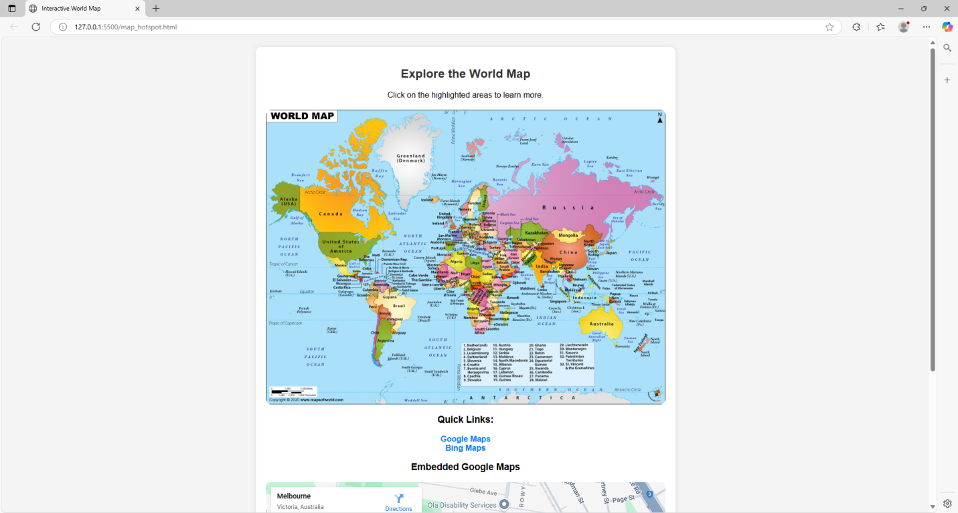

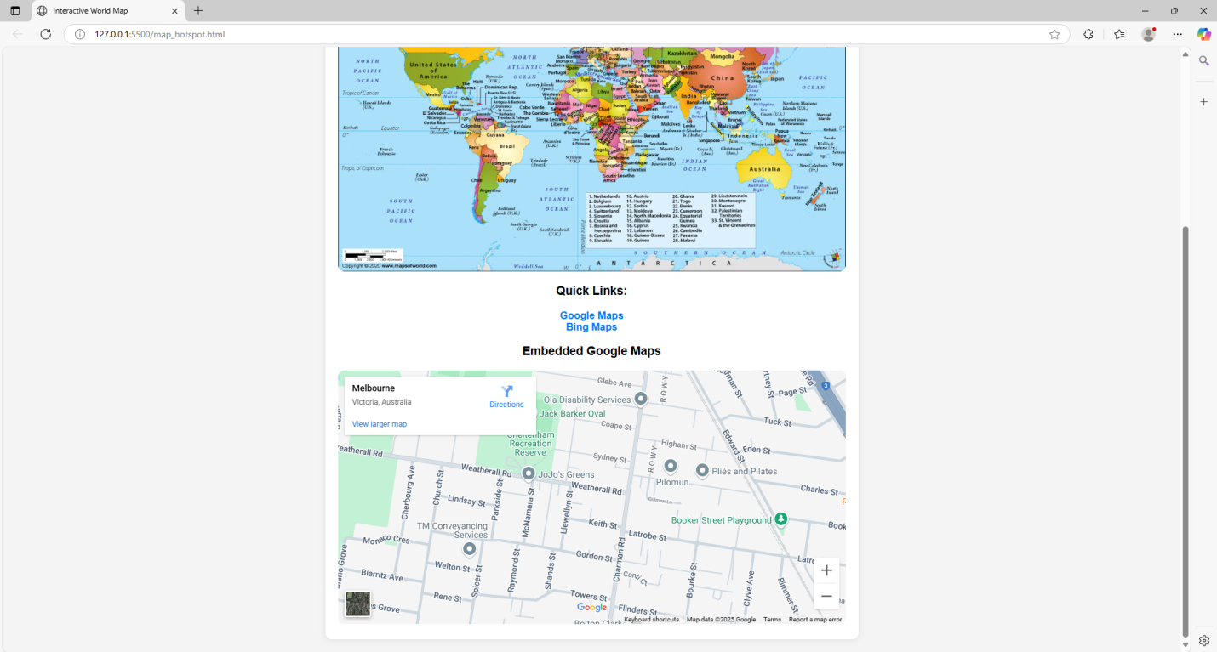

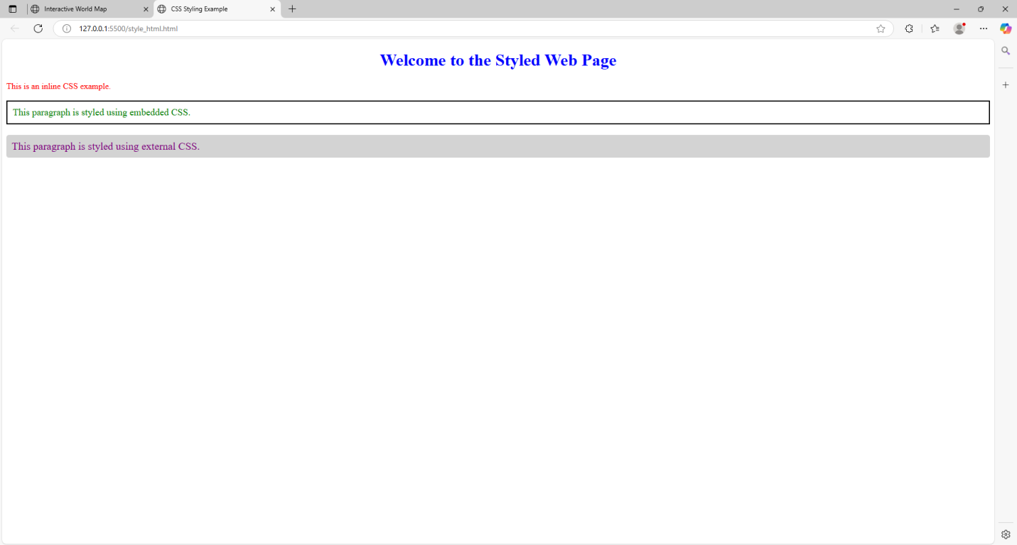

Result: Thus, a basic webpage with embedded maps, and a webpage illustrating different css was completed successfully.

